**Exercise: Configuring a Star schema**

**Introduction**

By now, you should be familiar with data models, cardinality, cross-filter direction and working with advanced data models.

In this exercise, you must apply your knowledge of these concepts by configuring a Star schema for Adventure Works using Microsoft Power BI. By completing this exercise, you'll demonstrate your ability to:

* Improve data analysis.
* Enhance reporting and visualization.
* Ensure data standardization and consistency.
* Simplify data navigation.

**Adventure Works case study**

Adventure Works wants to analyze its **Sales** data to generate insights into its business. It needs to create a data model using a Star schema. You can help the company to build this schema using the datasets within the workbook *AdventureWorksData*.

[Adventure Works Data](https://d3c33hcgiwev3.cloudfront.net/VzTCLjhdQcCA1sNl9mDvRA_23212e6d8b8246b5ad8670e567dc0ee1_Adventure-Works-Data.xlsx?Expires=1709942400&Signature=HHEaWrOo9bUwqg9QHNWd4uU3WJUqvW6Zc8H4zGkzm3Ri3t5xCUvXaqZlNlYb-XsmmWTn2ulRQOwZCSZEK2Jg6JU9xwnT99hUeyk4u8G7MA2HXN1OKXOgvjqpUnqh3lyoWRdLkPtOZCmE4NtQvvSGs-mo2tc6f1aBDbYhaMaOzw8_&Key-Pair-Id=APKAJLTNE6QMUY6HBC5A" \t "_blank)

[XLSX File](https://d3c33hcgiwev3.cloudfront.net/VzTCLjhdQcCA1sNl9mDvRA_23212e6d8b8246b5ad8670e567dc0ee1_Adventure-Works-Data.xlsx?Expires=1709942400&Signature=HHEaWrOo9bUwqg9QHNWd4uU3WJUqvW6Zc8H4zGkzm3Ri3t5xCUvXaqZlNlYb-XsmmWTn2ulRQOwZCSZEK2Jg6JU9xwnT99hUeyk4u8G7MA2HXN1OKXOgvjqpUnqh3lyoWRdLkPtOZCmE4NtQvvSGs-mo2tc6f1aBDbYhaMaOzw8_&Key-Pair-Id=APKAJLTNE6QMUY6HBC5A" \t "_blank)

**Instructions**

**Step 1: Download the Excel file and disable autodetect relationships in Power BI**

1. Download and save the Excel workbook **AdventureWorksData.xlsx**. The workbook contains four tables of data: **Sales**, **Products**, **Region**, and **Salesperson**.
2. Disable Power BI’s **autodetect** function.

* **Tip:** You can download the workbook from this page by selecting the attached Excel file. Its contents should resemble the following screenshot.

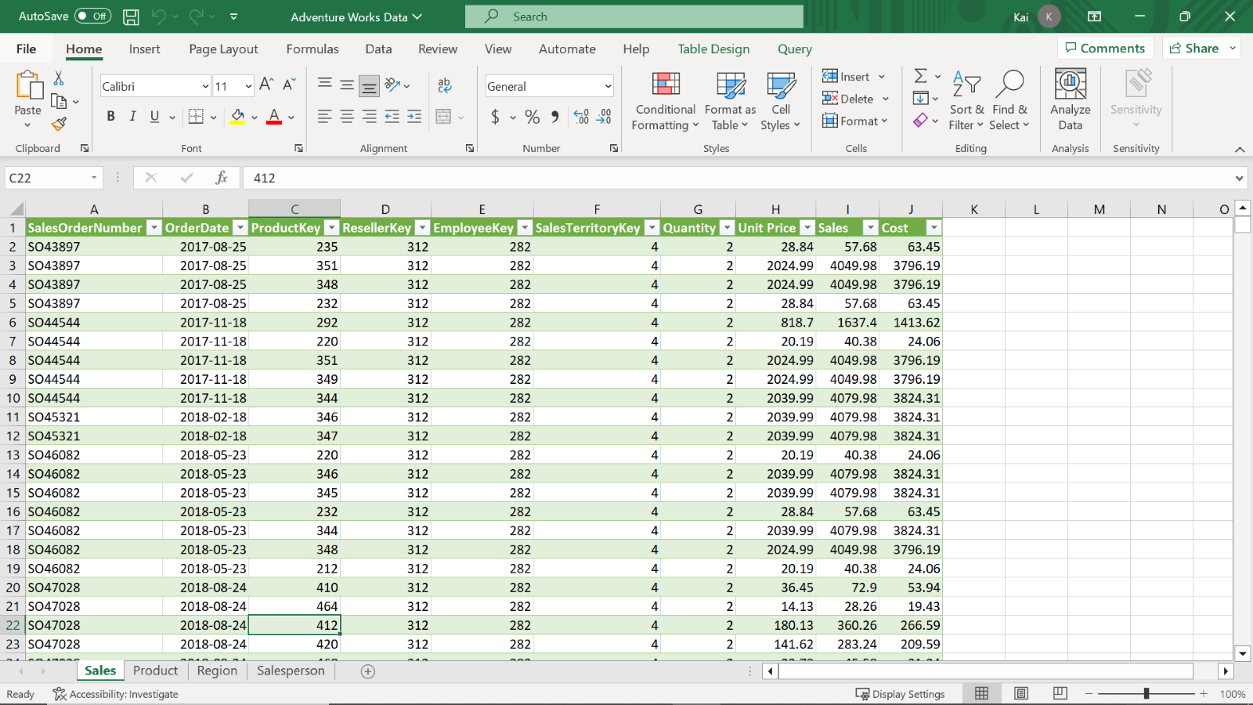

**Step 2: Load the data from the Excel workbook.**

1. Load the data from the Excel sheet into Power BI. Ensure you load all tables in the workbook.
2. Open a preview of the table in the **Preview** pane.

* **Tip:** You can import data using the **Get Data** drop-down menu.

**Step 3: Configure a Star Schema.**

1. Once the data is loaded to Power BI, Identify the main fact table in your dataset and determine the unique identifier for the fact table.
2. Identify the related dimension tables within your dataset and determine the unique identifiers for each dimension table.
3. Establish relationships between the fact and dimension tables based on the common fields.

* **Tip:** You can create a data model in the **Model view** of Power BI desktop. If Power BI autodetects the table relationships (as in most cases), you need to delete the existing relationships before you create new ones.

1. Next, configure the relationships. For example, establish cardinality type and cross-filter direction between the Fact and dimension tables.
2. Review the data type and formats of the columns and adjust them if necessary. Apply any necessary transformation to prepare the data for analysis, if needed (Note that this step is optional).

* **Tip:** You can configure relationships in the **Edit Relationship** dialog box and apply any required transformations in the **Power Query editor**.

**Step 4: Save the Power BI Project.**

* Save your Star schema project to your local computer.
* **Tip:** Select an appropriate project name and folder path for your schema.

**Conclusion**

Congratulations! You have successfully configured a Star schema for the Adventure Works dataset in Microsoft PowerBI. This new data model should now provide an efficient structure for querying and reporting on the data.

In addition, the knowledge you’ve gained through this exercise empowers you to tackle complex datasets, uncover meaningful insights, and deliver impactful reports and visualizations to drive informed decision-making.

# **Exemplar: Configuring a Star schema**

**Overview**

In the exercise *Configuring a Star schema*, you were asked to put into practice your knowledge of data models by configuring a Star schema.

Your tasks in this exercise were to:

* Download the required dataset.
* Load the dataset into Power BI.
* Configure the dataset as a Star schema.

This reading provides you with a step-by-step guide for completing these tasks. It also includes screenshots that you can compare against your work.

You can review the techniques for configuring a Star schema in the video[*Setting up a Star schema in Power BI*](https://www.coursera.org/learn/data-modeling-in-power-bi/lecture/94qwn/setting-up-a-star-schema-in-power-bi).

**Power BI Desktop User Interface**

While reviewing these steps, you may see changes in the user interface (UI). Power BI Desktop is updated and released monthly, incorporating customer feedback and new features.

You might experience changes in the Power BI Desktop UI that have taken place after the development of this training content. As a result, the screenshots in the videos, readings, or exercises might not align exactly with how you experience the UI.

However, please note that these changes do not impact the functionalities of the UI. This means you can still perform all the steps shown in that video, reading, or exercise.

**Step 1: Download the dataset and disable autodetect relationships in Power BI.**

1. Download the **Adventure Works Data.xlsx** workbook from the exercise page on the Coursera platform.

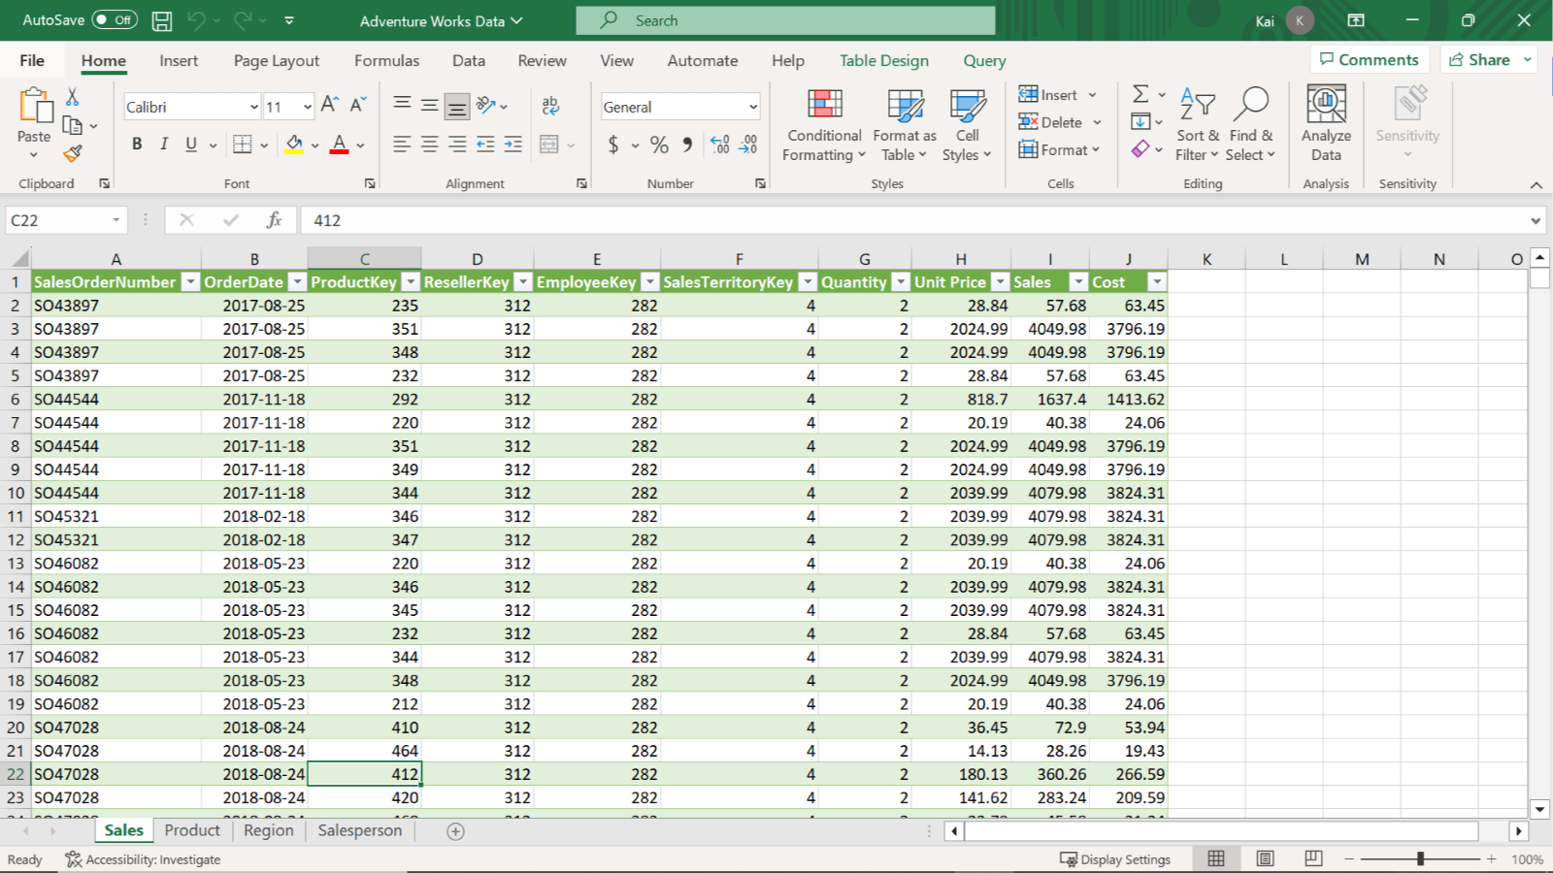

1. To disable autodetect functionality, select **File**, then **Options** and **Settings**, and select **Options**. This opens the **Options** dialog box.
2. On the left bar of the dialog box, select **Data Load** and then deselect **Autodetect new relationships** after the data is loaded. Then select **OK**.

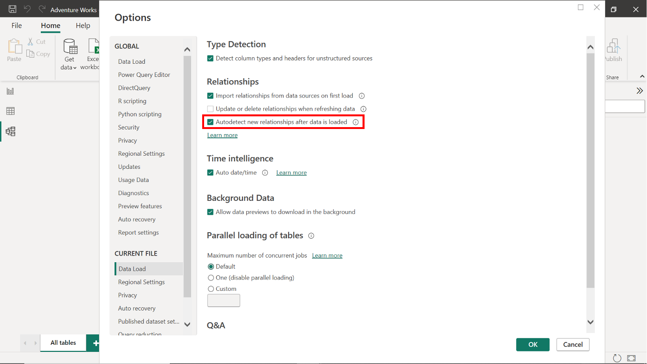

**Step 2: Load the data from the Excel workbook.**

1. Launch Power BI desktop and create a new project. To create a new project, select the **File** menu, then select **New**.
2. Import the Adventure Works dataset that you have downloaded. In the **Home** tab, select the **Get Data** drop-down menu. Then select an appropriate data source.
3. For the current exercise, select **Excel Workbook** and navigate to the folder containing the Adventure Works dataset.

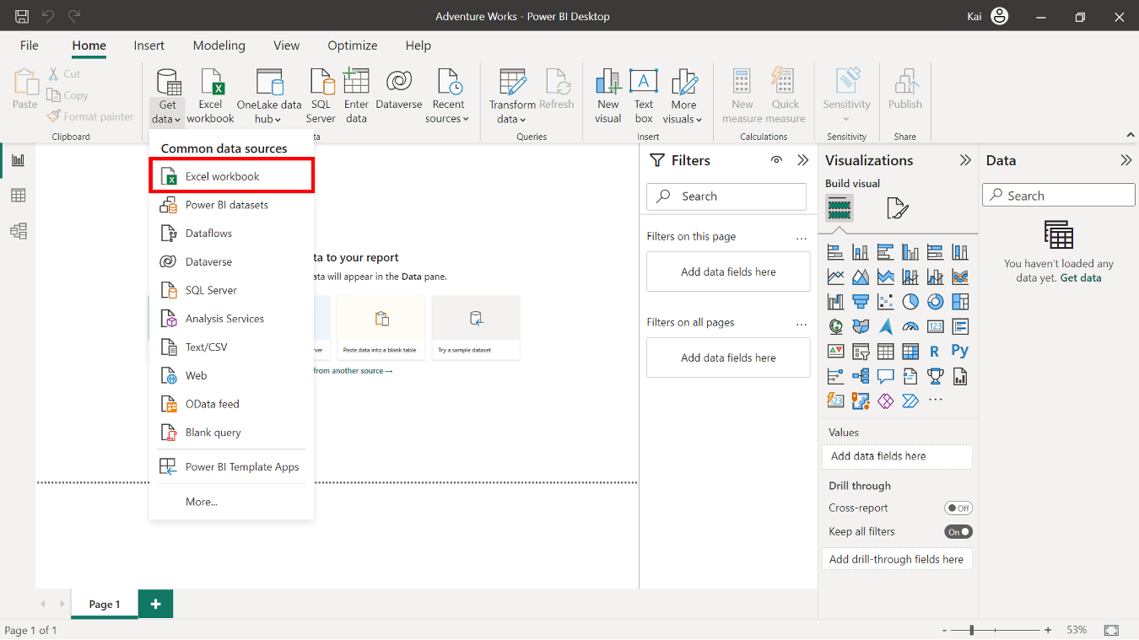

1. Once you select and load the data, Power BI opens a **Navigator** dialog box that enlists all the tables available to load in the Excel file and the data preview on the right side of the **Navigator**.
2. Select the **Sales**, **Product**, **Region**, and **Salesperson** tables, then select **Load**.

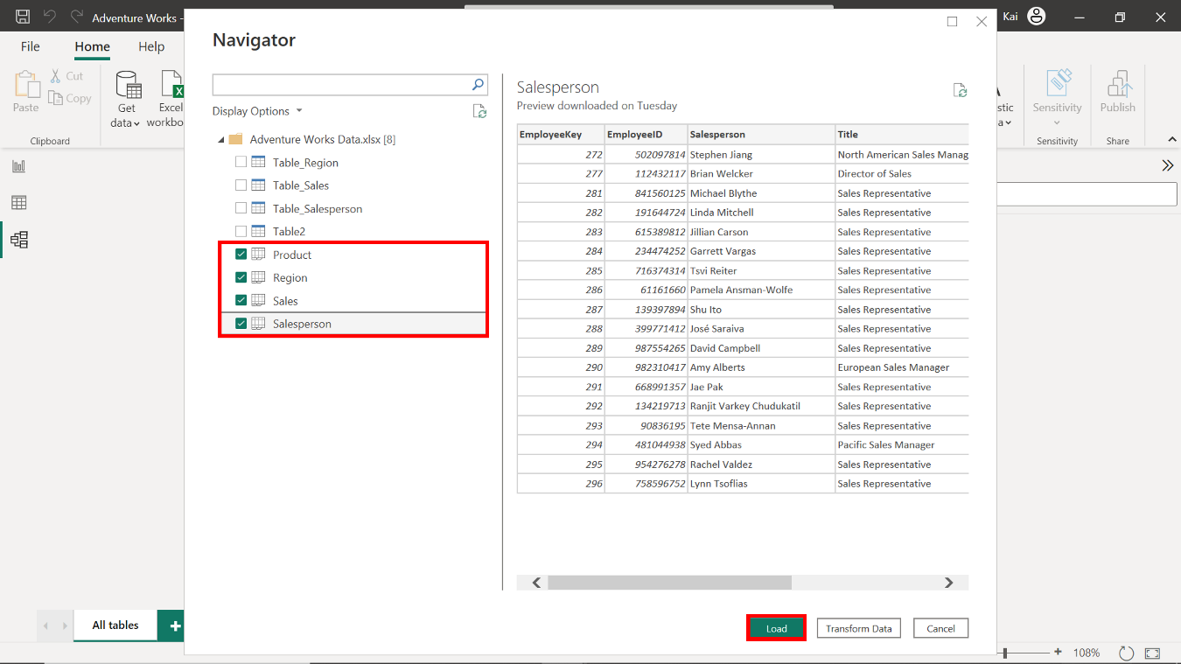

1. You can view the loaded dataset on Power BI desktop by selecting the **Data view** option from the left sidebar of the interface.

**Step 3: Configure a Star schema.**

1. A unique identifier is usually an ID column or key column within the data table. Once you select a column, Power BI displays the total number of rows at the bottom left corner of the interface with unique values. For the ID column, the number of rows and unique values should be the same.
2. In the Adventure Works dataset, the **Sales** table is the fact table that records transactional details.

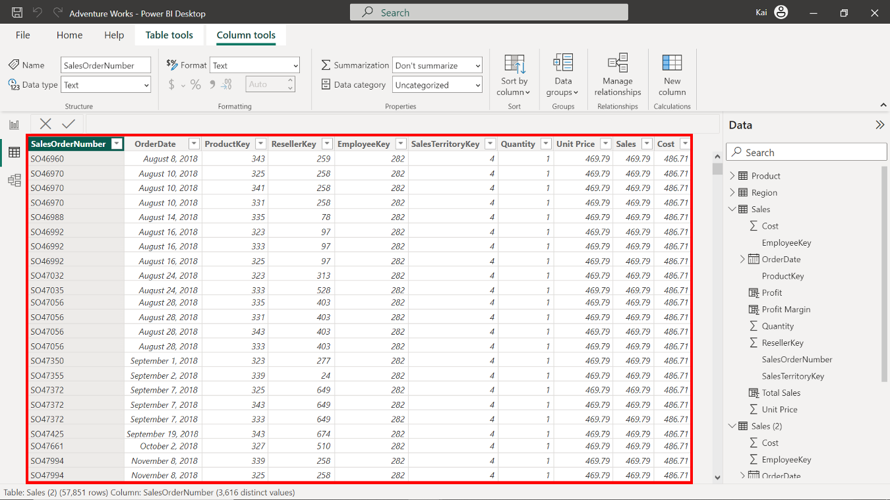

1. The **Products**, **Region**, and **Salesperson** tables are the dimension tables. To determine the unique identifier, check the total number of rows at the bottom left corner of the interface with unique values.

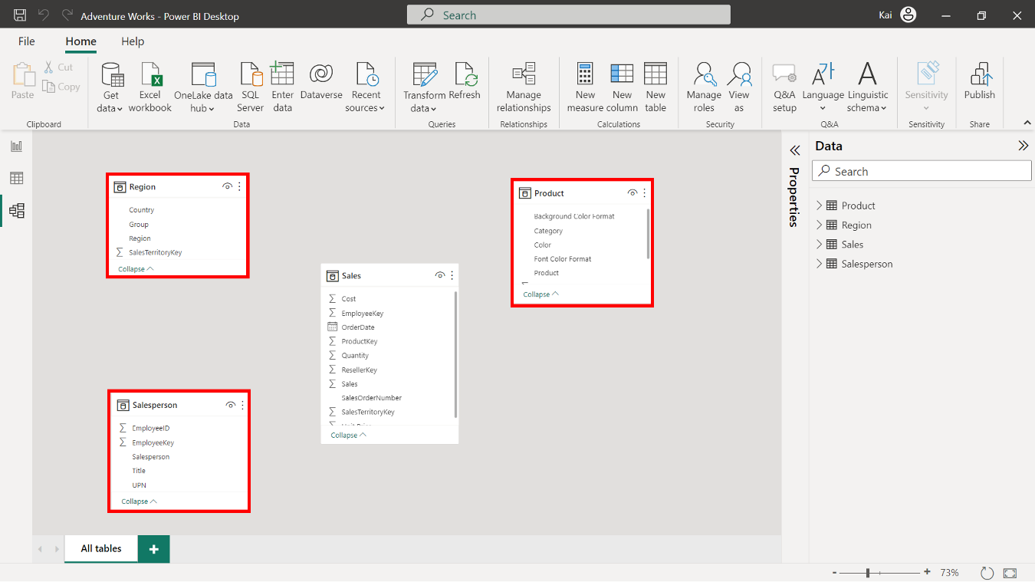

1. To create the schema and the model relationships between the fact table and the dimension tables, select **Model view** on the left sidebar of Power BI desktop.
2. You must establish relationships between the fact and dimension tables in the **Model view**. Select and drag the foreign key fields from the fact table to their corresponding primary key fields in the dimension tables.
3. Connect **Sales.ProductKey** to **Products.ProductKey**, then **Sales.SalesTerritoryKey** to **Region.SalesTerritoryKey**, and finally, **Sales.EmployeeKey** to **Salesperson.EmployeeKey**.
4. Alternatively, you can build relationships using the **Create Relationship** dialog box. Access the dialog box by selecting **Manage Relationship** in the **Model view** of Power BI desktop.

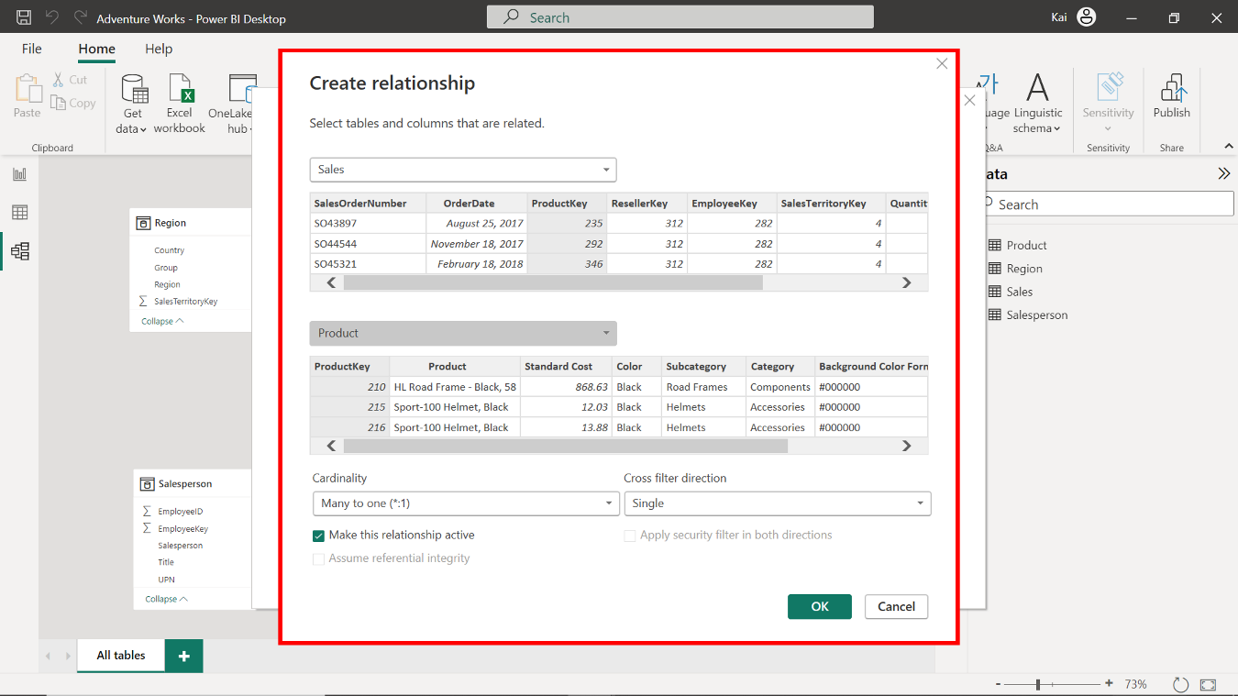

1. Once the relationships are established, double-check to ensure each type is a many-to-one relationship. Select the **connector line** between the tables to open the **Edit Relationship** dialog box. Here you can verify that the cardinality is set to **Many-to-One** and that the cross-filter direction is set to **Single**.

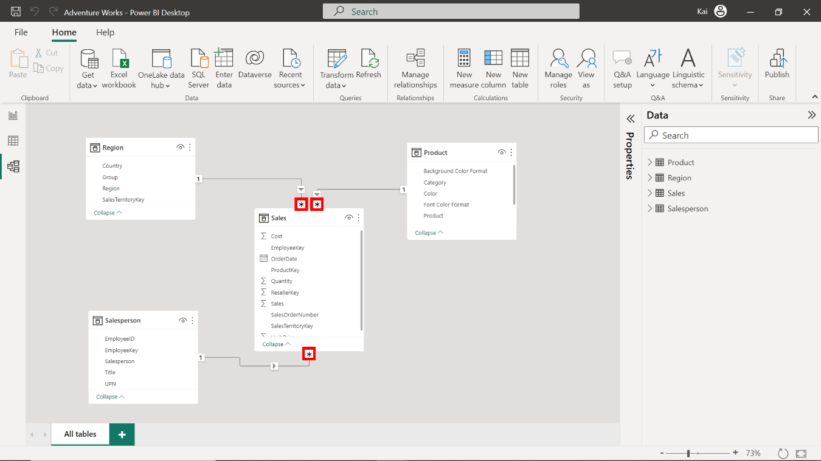

**Step 4: Save the Power BI project.**

1. To save the project, open the **File** menu, select **Save As** and provide an appropriate name for the project along with a path to the folder on your local machine.

**Conclusion**

Upon completing these steps, you will have successfully configured a Star schema for the Adventure Works dataset, allowing for easier analysis and reporting of the sales data.